TSANet Connect

Salesforce Install Guide

# Install / Uninstall Package.

**Note:** Please ensure an existing Beta package is not installed, as it will give an error. You need to uninstall the preview package and install the new one. Before uninstalling the old package, you must remove the LWC from the Case page.

# Install the Package

Obtain the link to the latest version of the package at the TSANet Github Connect 2 Release site: <https://github.com/tsanetgit/SFDC>

Copy the link from the Github readme into your browser and login to your Salesforce to start the process.

Select Install for All Users and checkbox below -> Click Install -> Select checkbox: Yes, grant access to these third-party websites -> Click Continue.

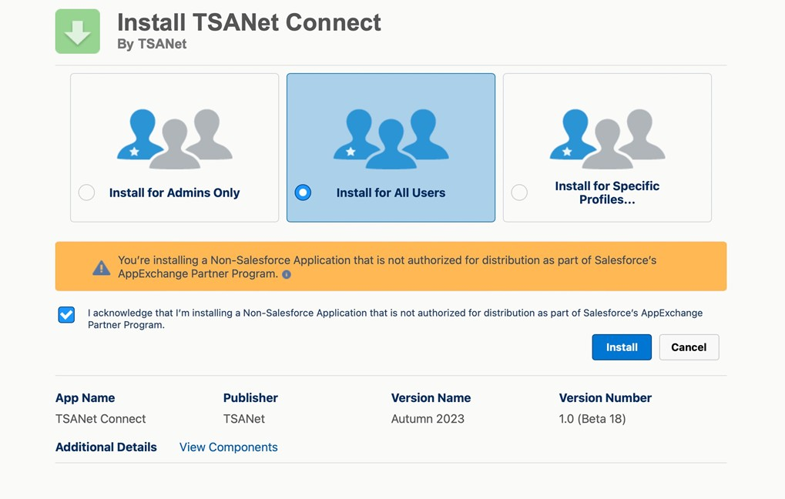

Screen below will show the version you are installing.

# Configuration with TSANet Credentials

The packages uses Basic Authentication to communicate with TSANet Connect. An API user is created on the Member account and used in the process below.

# Permission Sets for the package

Create a new record with the provided credentials, set the environment, and mark this connection as the primary live one. **Only the ‘Is Primary’ credential is used** and must be selected.

## Environments: TSAnet has the following environments

* Developer: Only used by developers who are making changes to the package
* Beta: Used by Members to test before moving to production
* Prod: User by Members in Production

# Setup TSANet Cases List:

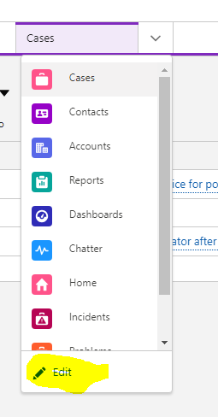

>Go to the Service Console.

>Select Edit for the List dropdown:

>Select Add More Items

>Add TSANet Cases list

>Select Add More Items

>Add TSANet Cases list

# Setup TSANetApplication component:

Go to the Case record page. Click Gear Icon, then Edit Page button. Find the

TSANetApplication component and drag and drop it to the appropriate place -> Click Save.

Note: Other options for Case page customizations are available using flows and actions. See the Case Customization section at the end of this document for details.

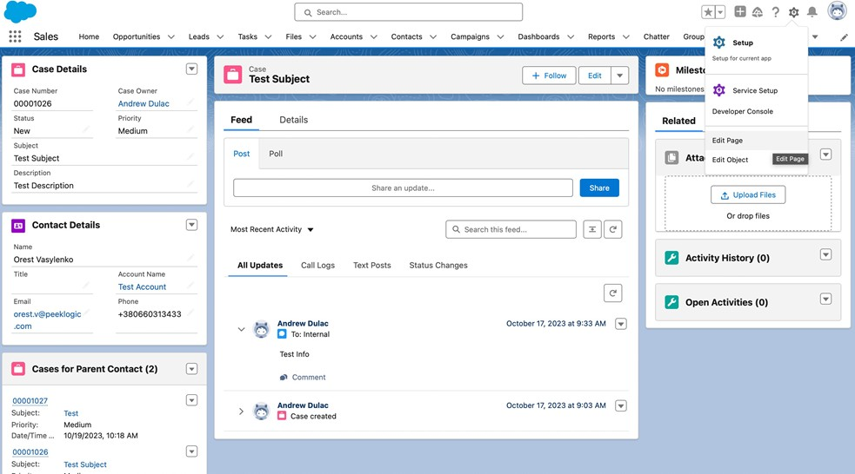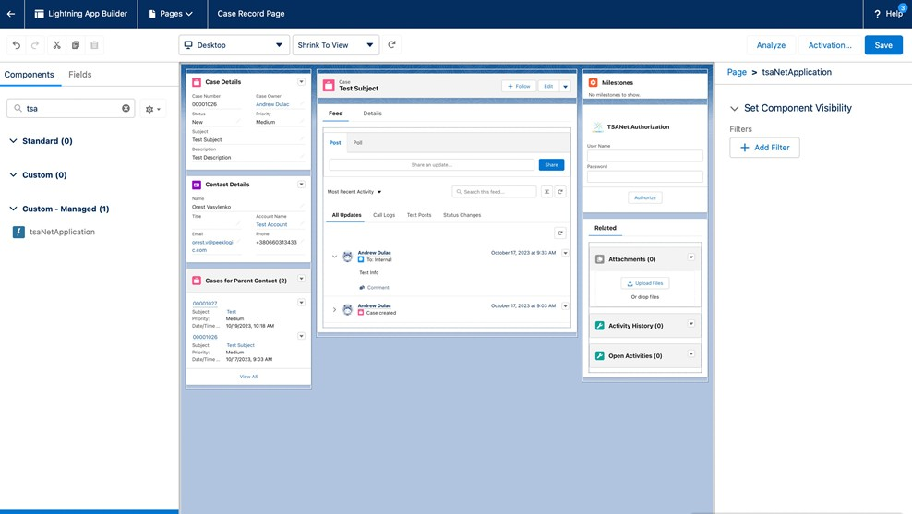

Click the Activate button -> Select APP DEFAULT tab -> Click Assign as App Default -> Choose your app -> Click Next button and assign desktop and phone version -> Click Next and Save button.

**Add the TSANet Case-related list view to the Case page layout.**

Go to Setup -> Object Manager -> Case -> Page layout -> Select your page layout -> Scroll to related list section -> Drag n drop TSANetCase related list to layout -> Save.

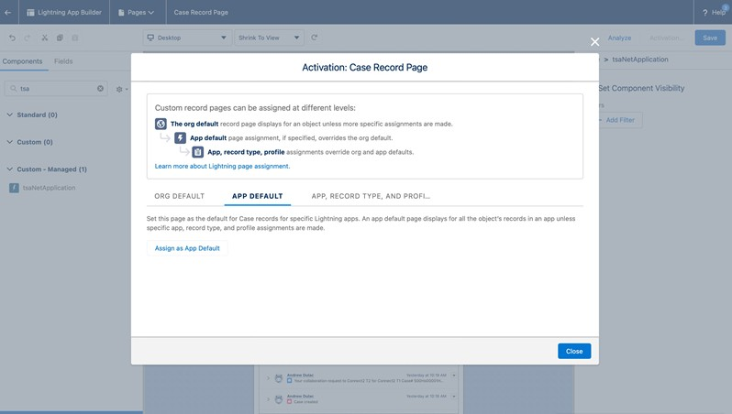

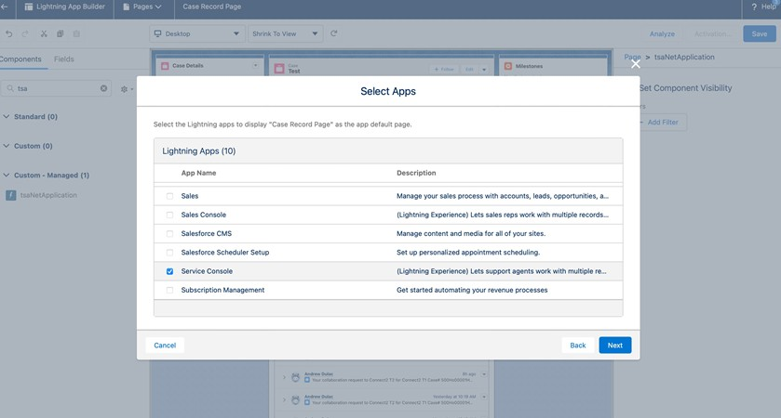

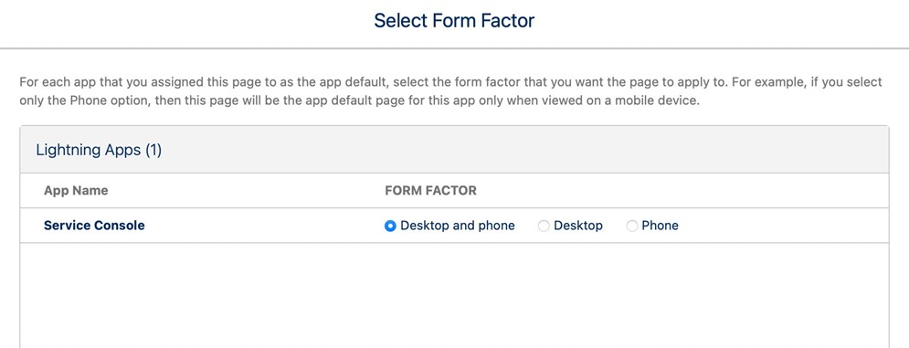

# Assign Users to TSANet Connect Permission Set

Go to Setup -> Permission Sets -> Search and Select TSANet Connect Permissions (Admin) or TSANet Connect Permissions (Employee) -> Click Manage Assignments button -> Click Add Assignment button -> Select Users -> Click Next button -> Select an Expiration Option For Assigned Users and click Assign button -> Done.

# Package Details and Configuration Options

Work with Orest and IBM to document the following:

1. What is included in the Salesforce Package (Objects, Flows actions…)
2. How flows and actions can be used in further package customization. Check with IBM if we can document how they have modified their case page as a reference

# Visual Studio setup

This section is for developers who work on code modifications to the package.

**Step 1: Install Visual Studio Code**

Download and install Visual Studio from the oﬃcial Microsoft website.

Link: <https://visualstudio.microsoft.com/ru/free-developer-offers/>

**Step 2: Install Salesforce CLI (command-line interface)**

If you haven't already, download and install CLI

Link: https://developer.salesforce.com/tools/salesforcecli

**Step 3: Install Salesforce Extension Pack**

1. Open Visual Studio.

2. Go to the Extensions menu, then select "Manage Extensions."

3. In the Extensions window, search for "Salesforce Extension Pack."

4. Click on the "Download" button and then click "Install" to install the extension pack.

5. Restart Visual Studio to activate the extension pack.

**Step 4: Create or Open a Salesforce Project**

1. In Visual Studio, go to the File menu, then select "View" > "Command

Palette…">”SFDX: Create Project with Manifest”>Enter Project Name

2. Specify location, then click "Create."

3. If you already have a Salesforce project, you can open it by selecting "Open

Folder" from the File menu and navigating to the project directory.

**Step 5: Connect Visual Studio to Your Salesforce Org**

1. Go to the View menu, then select "Command Palette."

2. In the Command Palette, type "SFDX: Authorize an Org" and press Enter.

3. Choose the appropriate option to log in to your Salesforce org

4. Follow the prompts to complete the authentication process.

**Step 6: Retrieve Source From ORG**

1. After creating or opening the project, locate the Manifest folder in the Solution

Explorer panel on the left side of the Visual Studio window.

2. The Manifest folder contains metadata ﬁles (e.g., package.xml) that deﬁne the components to retrieve from the Salesforce org.

3. right-click on package.xml ﬁle and choose "Retrieve Source with Manifest from Org."

**Step 7: Deploy Source To ORG**

1. right-click on package.xml ﬁle and choose "Deploy Source with

Manifest To Org."

